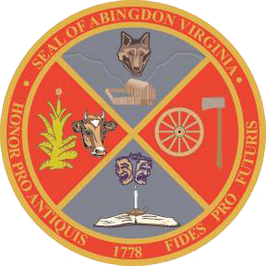
Town of Abingdon, Virginia
Abingdon Arts Commission
Monday, March 13, 2023 – 4:00 p.m.
Town Hall of Abingdon, Arthur Campbell room, first floor

- WELCOME (Greg Lilly)
- CALL TO ORDER (Greg Lilly)
- ROLL CALL (Chad Thompson, town staff)
- APPROVAL OF MINUTES (all)
- OLD BUSINESS
- Finance Committee’s departmental and non-departmental reviews, 3/23
- Town Council Meeting to review our year, Monday, 4/3, 6:30 p.m.
- NEW BUSINESS
- Review & revise Letter of Funding format
- Review & revise Memo of Understanding draft
- Assign organizations’ commissioner liaisons to monitor the projects.
- Review & revise Year-End Report format.
- Discuss our projects – what are some things the AAC can do to help with expanding arts – policies, programs, cultural events?
- Discuss Ellen Elmes’ Mural on 301 W. Main, at Lois H. Humphreys Park
- NEXT COMMISSION MEETING – Monday, May 8, 2023
- ADJOURNMENT

