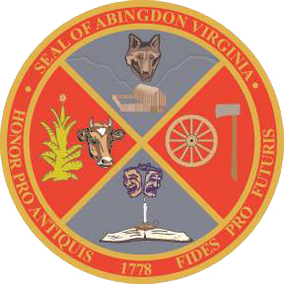
Town of Abingdon, Virginia
Abingdon Arts Commission
Monday, January 9, 2023 – 4:00 p.m.
Town Hall of Abingdon, Arthur Campbell room, first floor

- WELCOME (Greg Lilly)
- CALL TO ORDER (Greg Lilly)
- ROLL CALL (Chad Thompson, town staff)
- APPROVAL OF MINUTES (all)
- OLD BUSINESS
  - none
- NEW BUSINESS
  - Review, discuss, and score grant request applications (all)
  - Establish a final budget recommendation (all)
  - Arts funding recommendation schedule:
    - January – Submit written recommendation to Finance Department
    - February – present at Finance Committee’s departmental budget meeting
    - March – present to Town Council on recommended arts funding
- NEXT COMMISSION MEETING – Monday, March 13, 2023, or combine with the March Town Council meeting
- ADJOURNMENT

