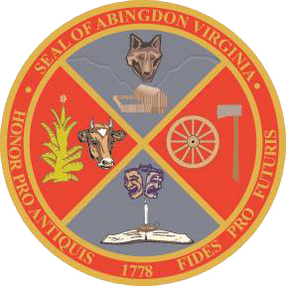
Town of Abingdon, Virginia
Abingdon Arts Commission
Monday, November 14, 2022 – 4:00 p.m.
Town Hall of Abingdon, Arthur Campbell room, first floor

- WELCOME (Greg Lilly)
- CALL TO ORDER (Greg Lilly)
- ROLL CALL (Matt Fredericks [Chad Thompson, town staff, is out of the office])
- APPROVAL OF MINUTES (all)
- OLD BUSINESS
  - Review of Informational Meetings for arts non-profits (all)
- NEW BUSINESS
  - Schedule grant review requests (all)
  - Review and update draft of grant scoring sheet (all)
  - Set schedule for receiving and reviewing grant requests (all)
  - Set date to present to Town Council on recommended arts funding (all)
  - Set date to deliver budget recommendation to Finance Department (all)
- NEXT COMMISSION MEETING – Monday, January 9, 2023
  - Reminder of 2023 AAC meeting dates (second Monday, odd months, at 4:00): January 9, March 13, May 8, July 10, September 11, November 13.
- ADJOURNMENT

