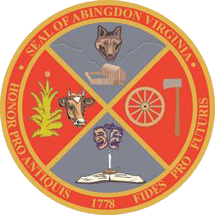
Town of Abingdon, Virginia
Abingdon Arts Commission
Monday, July 11, 2022 – 4:00 p.m.
Town Hall of Abingdon, Arthur Campbell room, first floor

- WELCOME
- CALL TO ORDER Greg Lilly welcomed everyone to the meeting and called the meeting to order at 4:01pm
- ROLL CALL Katie Garrett called role: Greg Lilly, Summer Apostol, Amanda Pillion, Ben Jennings and Matthew Frederick were all present. Dirk Moore was not present at roll call, but arrived at 4:30pm.
- APPROVAL OF MINUTES Matthew Frederick made motion that minutes be approved from the May 9, meeting, second by Amanda Pillion. Minutes approved unanimously.
- OLD BUSINESS
  - Approve Project Grant Guidelines (all)
Ben requested clarification of what was meant by “services to the field”, Greg described it as if an organization wanted to hold a series of classes to benefit artisans or art organizations as a whole.
Matt requested re-wording to clarify the 1:1 required cash match for the grant. Will reword it to 1:1 organizational match.
Amanda Pillion made the motion that the guidelines be approved, Matthew Frederick made the second. Guidelines approved unanimously.
  - Approve Project Grant Application (all)
Dirk More made the request that organizations provide their strategic plan. Application will be amended to make the strategic plan optional for applicants.
Ben Jennings made the motion that the application be approved, Matthew Frederick made the second. Application was approved unanimously.
  - Review initial list of arts non-profits based or providing services in Abingdon (all)
Reviewed list as group.
  - Review Finance Department’s initial target funding amount for FY2024 budget (Greg Lilly)
Discussed that we will need to take a request for a “reasonable amount” of funding to the Finance Committee/Town Council to present during budgeting
- NEW BUSINESS
  - Set two dates for Informational Meetings to arts non-profits on Arts Commission’s purpose and process (all)
Dates set: Monday, 9/26 at 9:30am and 5:00pm
  - Review of the Town’s electronic meeting policy (Katie Garrett – town staff)
  - Review of Commitment to Excellence policy, for commissioners’ signatures (Katie Garrett – town staff) Read over policy as a group, returned signed copy to Katie to give to Kim Kingsley
  - Review of Ordinance regarding Boards, Commissions, and Committees (Katie Garrett – town staff) Read over ordinance

- NEXT MEETING – Monday, September 12, 2022
  - Approve agenda for Informational Meetings
  - Assign tasks for Informational Meetings
- ADJOURNMENT Meeting adjourned at 4:34

