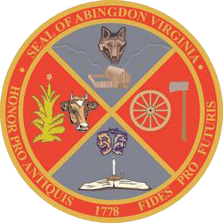
Town of Abingdon, Virginia
Abingdon Arts Commission
Monday, July 11, 2022 – 4:00 p.m.
Town Hall of Abingdon, Arthur Campbell room, first floor

- WELCOME
- CALL TO ORDER
- ROLL CALL
- APPROVAL OF MINUTES
- OLD BUSINESS
  - Approve Project Grant Guidelines (all)
  - Approve Project Grant Application (all)
  - Review initial list of arts non-profits based or providing services in Abingdon (all)
  - Review Finance Department’s initial target funding amount for FY2024 budget (Greg Lilly)
- NEW BUSINESS
  - Set two dates for Informational Meetings to arts non-profits on Arts Commission’s purpose and process (all)
  - Review of the Town’s electronic meeting policy (Katie Garrett – town staff)
  - Review of Commitment to Excellence policy, for commissioners’ signatures (Katie Garrett – town staff)

  - Review of Ordinance regarding Boards, Commissions, and Committees (Katie Garrett – town staff)
- NEXT MEETING – Monday, September 12, 2022
  - Approve agenda for Informational Meetings
  - Assign tasks for Informational Meetings
- ADJOURNMENT

