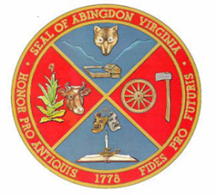
TOWN OF ABINGDON, VIRGINIA
P. O. BOX 789
ABINGDON, VIRGINIA 24212

ADDENDUM NO. 1
Date: September 22, 2021

RE: ITB Stair Replacement to the Bridge over Norfolk-Southern Railroad

This addendum herein supplements, modifies, changes, deletes from or adds to the original bidding documents for the project noted above and is herein made a part of the contract documents and shall apply to items incorporated in the Addendum.

Clarifications:
- The purpose of this clarification is to provide final direction to all bidders.
Page 5, The Pre-Bid Meeting scheduled for September 30, 2021 at 2:00 p.m. is NON-mandatory.

End of Addendum 1

A signed acknowledgment of this addendum should be received at the location indicated on the RFQ either prior to the due date and hour or attached to your response. Signature on this addendum does not substitute for your signature on the original bid document. The original bid document must be signed.

_____________________________________
Name of Firm
______________________________________ ______________________
Signature/Title Date

