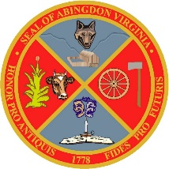

TOWN OF ABINGDON
Abingdon, Virginia

THE BOARD OF ZONING APPEALS
REGULARLY SCHEDULED MEETING
FOR TUESDAY, MAY 12, 2020
AT 6:00 P.M. LOCATED IN THE
AURTHUR CAMPBELL CONFERENCE ROOM
FIRST FLOOR
133 W. MAIN STREET
HAS BEEN CANCELLED

For information regarding the meeting, please contact:
Janice Dornon
jdornon@abingdon-va.gov
276-628-3167

